BD – Guião3

João Torrinhas NºMec:98435, Diogo Torrinhas NºMec:98440

Turma P1 Grupo 9

**Ex1**

**a)**

**As relações da tabela são**: Cliente, Aluguer, Balcao, Veiculo, Tipo_Veiculo, Similaridade, Ligeiro e Pesado.

-**Cliente**(nome, endereço, num_carta, NIF);

-**Aluguer**(numero, duração, data, NIF, numero_balcao, matricula);

-**Balcao**(nome, numero, endereco);

-**Veiculo**(matricula, marca, ano, codigo);

-**Tipo_Veiculo**(código, arcondicionado, designação);

-**Similaridade**(codigo1, codigo2);

-**Ligeiro**(codigoTipo, numlugares, portas, combustivel);

-**Pesado**(codigoTipo, peso, passageiros);

**b)**

|  |  |  |  |
| --- | --- | --- | --- |
|  | Chaves candidatas | Chave primária | Chave estrangeira |
| Cliente | num_carta, NIF | NIF | - |
| Aluguer | Numero | Numero | NIF, numero_balcao, matricula |
| Balcao | Numero, endereco | Numero | - |
| Veiculo | Matricula | Matricula | Código_tipoVeiculo |
| Tipo_Veiculo | Codigo | Codigo | - |
| Similaridade | Codigo1, Codigo2 | Codigo1, Codigo2 | Codigo1, Codigo2 |
| Ligeiro | Codigo | Codigo | Codigo |
| Pesado | Codigo | Codigo | Codigo |

**c)**

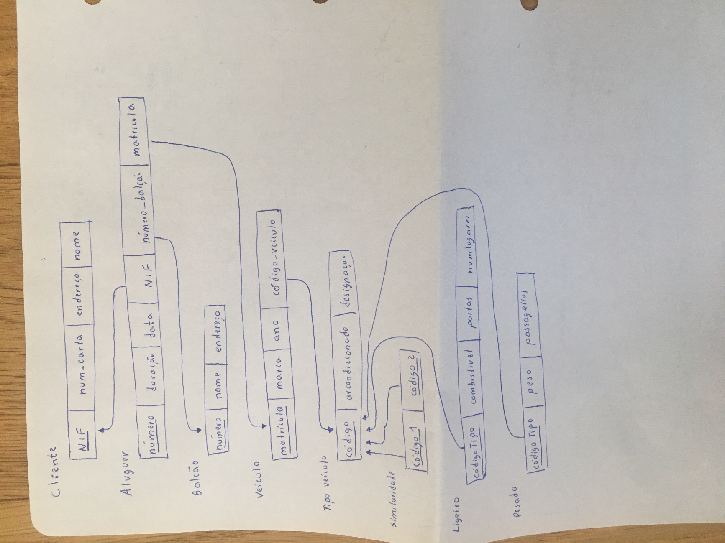

**Ex2**

**a)**

**As relações da tabela são**: Airport, Airplane_Type, Airplane, Flight_Leg, Flight, Fare, Leg_Instance, Seat e Can_Land.

- **Airport**(Airport_code, city, state, name);

- **Airplane_Type**(Type_name, Max_seats, company);

- **Airplane**(airplane_id, total_no_of_seats, type_name_airplane_type);

- **Flight_Leg**(number_flight, leg_no, airport_code, airport_code_arrival, scheduled_depart_time, scheduled_arrival_time);

- **Flight**(Number, airline, Weekdays);

- **Fare**(number_flight, code, restrictions, amount);

- **Leg_Instance**(number_flight, leg_number, date, no_of_avail_seats, depart_airport, arrive_airport, depart_time, arrive_time, plane);

- **Seat**(number_of_flight, leg_number, date, seat_no, customer_name, cphone);

- **Can_Land**(Airport_code, Type_name);

**b)**

|  |  |  |  |
| --- | --- | --- | --- |
|  | Chaves candidatas | Chave primária | Chave estrangeira |
| Airport | airport_code | airport_code | - |
| Airplane_Type | Type_name | Type_name | - |
| Airplane | airplane_id | airplane_id | type_name_airplane_type |
| Flight_Leg | number_flight, leg_no | number_flight, leg_no | number_flight, airport_code |
| Flight | Number | Number | - |
| Fare | number_flight, code | number_flight, code | number_flight |
| Leg_Instance | number_flight, leg_number, date | number_flight, leg_number, date | number_flight, leg_number, airport_code, plane |
| Seat | number_of_flight, leg_number, date, seat_no | number_of_flight, leg_number, date, seat_no | number_of_flight, leg_number, date |
| Can_Land | Airport_code, Type_name | Airport_code, Type_name | Airport_code, Type_name |

**c)**

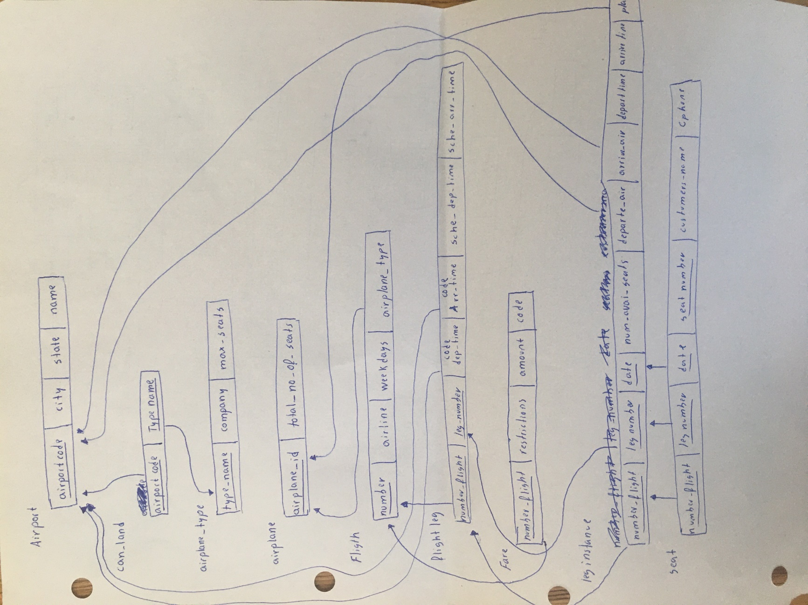

**Ex3**

**2.1)**

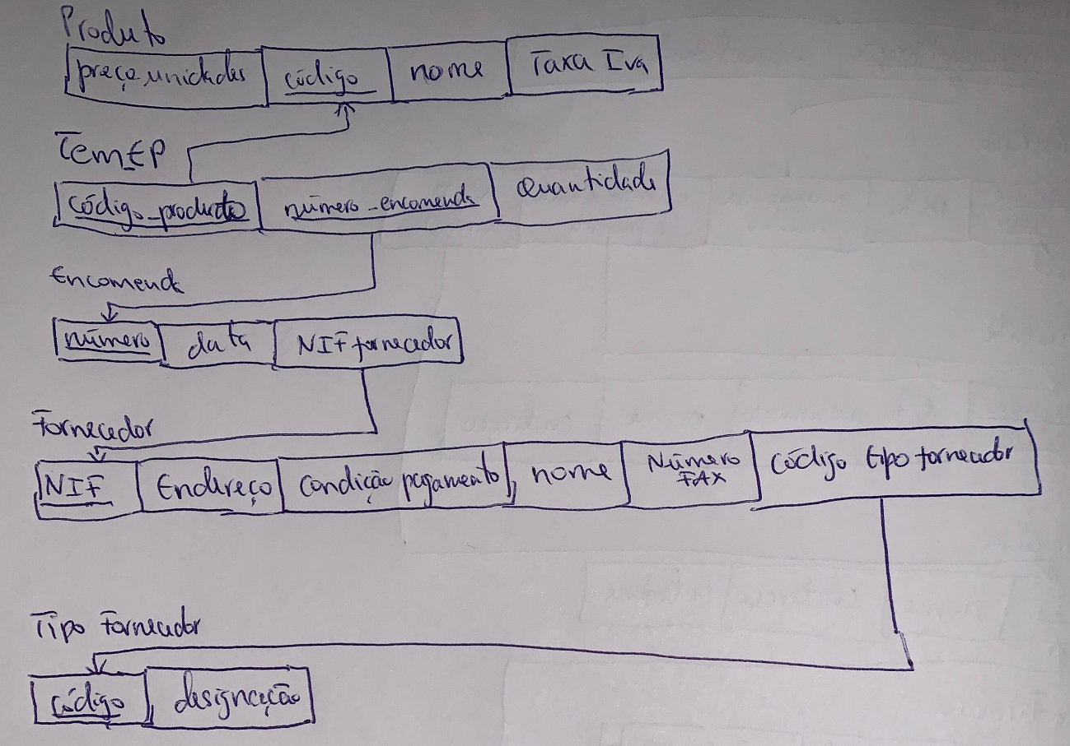

**2.2)**

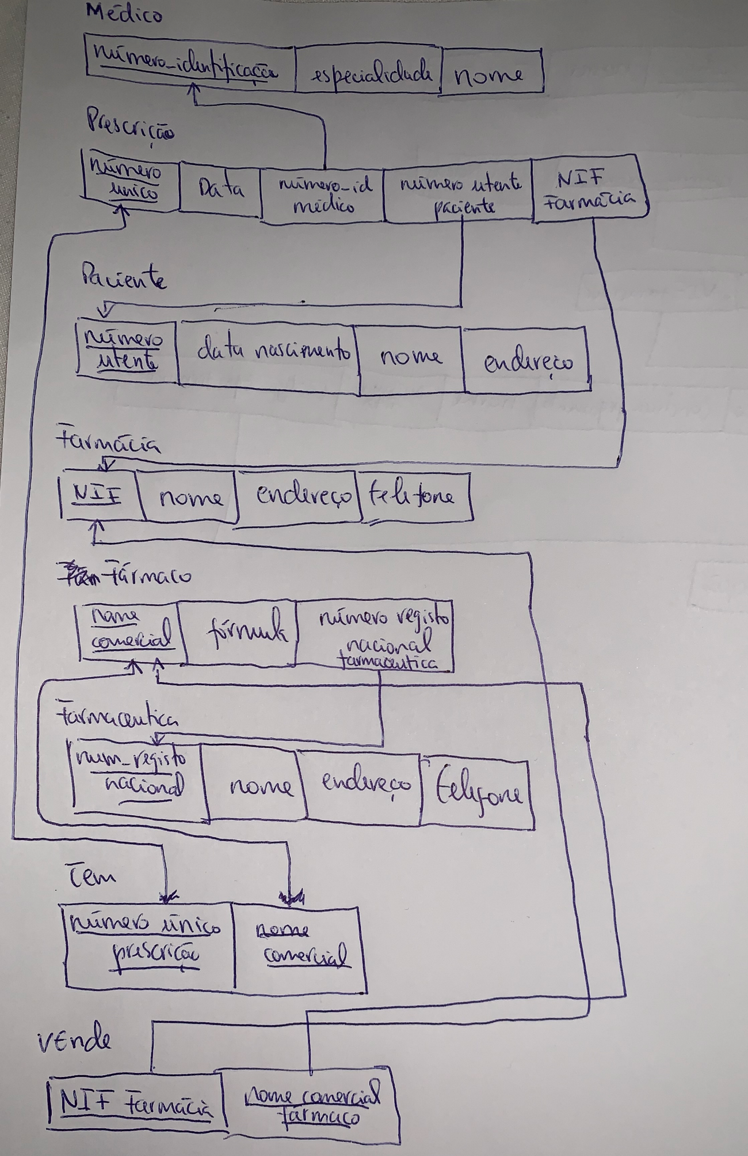

**2.3)**

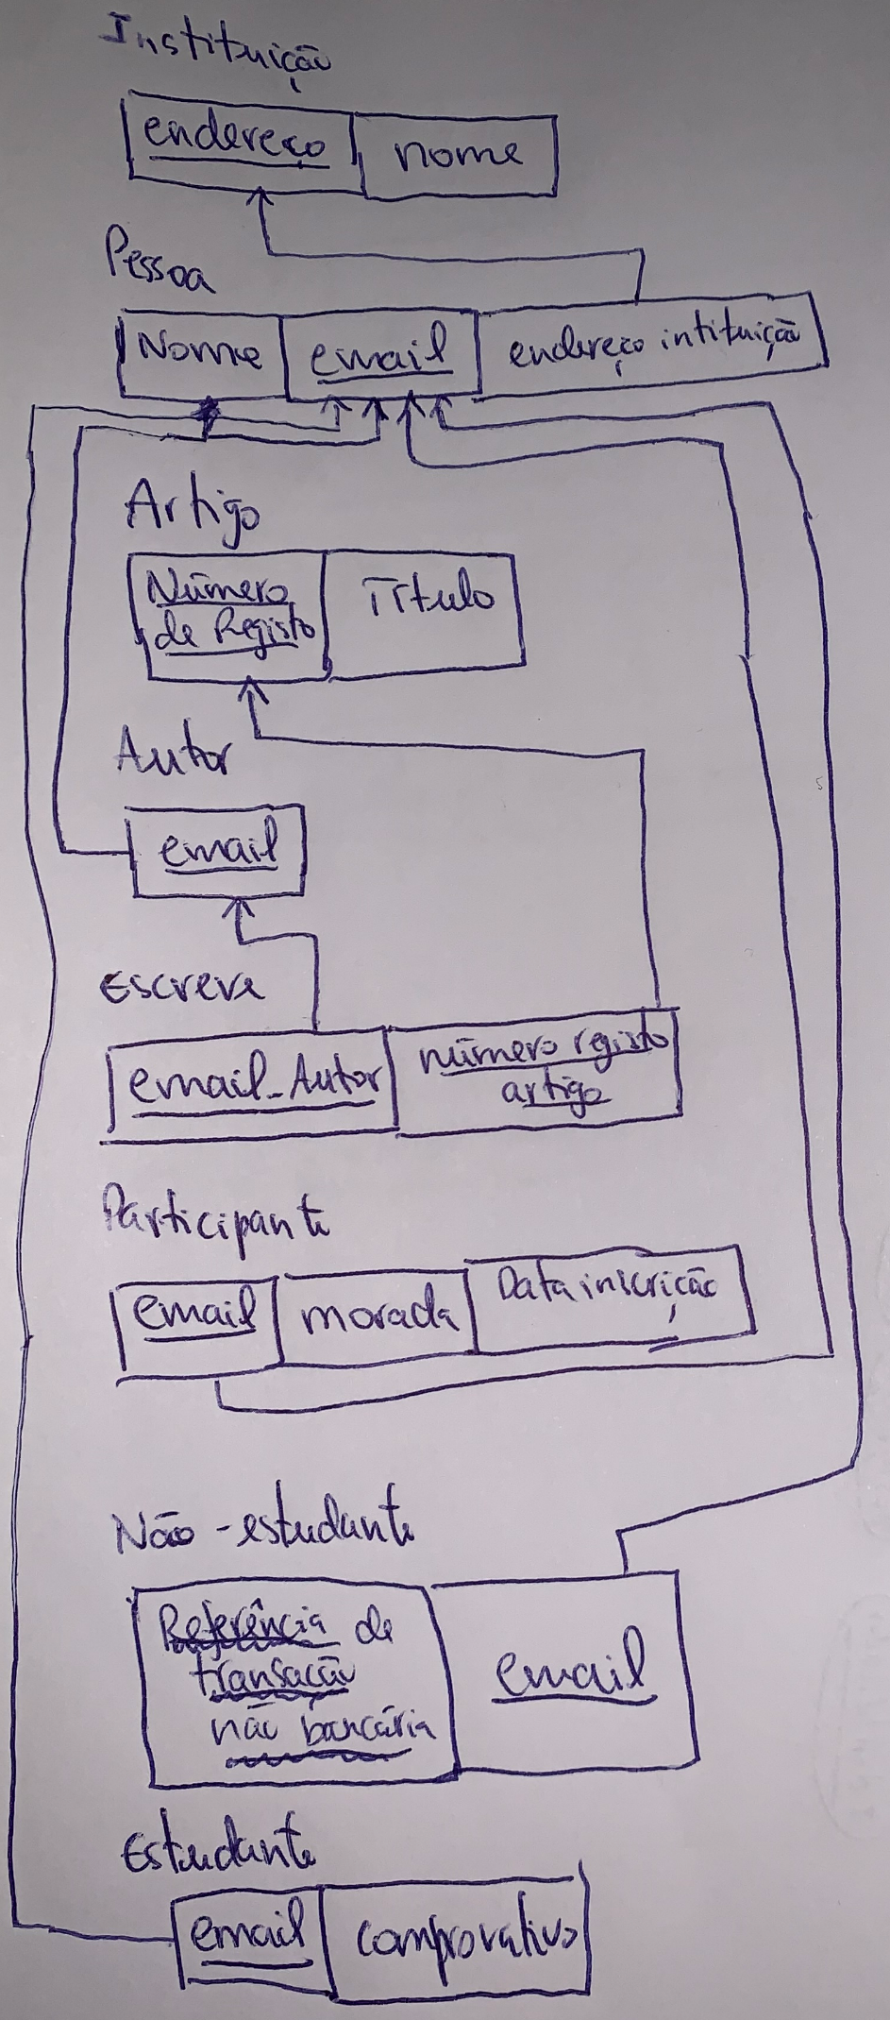

**2.4)**

